**Advance Excel Assignment 2**

1. What does the dollar($) sign do?

**Answer:**

**As,$M$4 is used to make this as absolute so while dragging it do not change with pattern but remain fix.**

1. How to Change the Reference from Relative to Absolute (or Mixed)?

**Answer:**

**As,$B$2 is used to make this as absolute so while dragging(during formula) it do not change with pattern but remain fix.**

1. Explain the order of operations in excel?

**PEDMAS:**

**Parenthesis(Bracket) >Exponents(Power)>Division>Multiplication>Addition>Substraction**

4. What, according to you, are the top 5 functions in excel and write a basic syntax for any of two?

**A. Vlookup**

**Syntax:**

**=vlookup(select cell you want search,select range in which you want to search, column number wrt**

**that searched cell,0)**

**B. Count:It counts total cells with Number datatypes**

**Syntax: =count(select range)**

**C .Counta: it counts total number of non-empty cells**

**Syntax: =counta(select range)**

**D . Countblank: it counts total number of empty cells**

**Syntax: =countblank(select range)**

**E. Countif: it counts the matching cells :**

**Syntax: =counta(select range,criteria)**

**F .other functions as sum,avg etc are also used timely.**

1. When would you use the subtotal function?

**Answer:**

**Say you want sum according to Region then we use subtotal .**

**Step-1:Sort the column**

**Step 2:Go to data select subtotal and perform as below.**

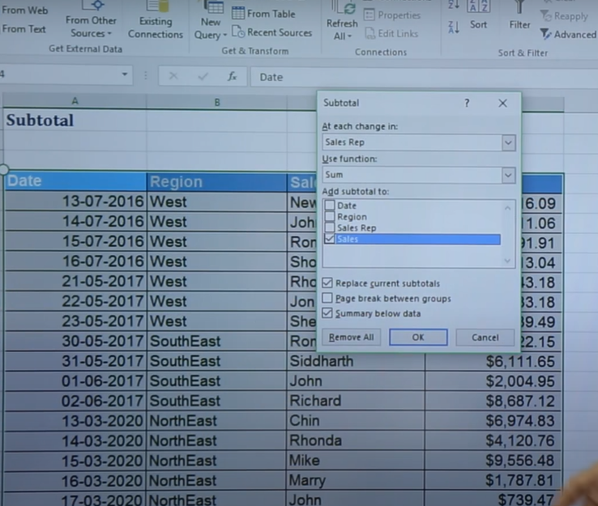

6. What is the syntax of the vlookup function? Explain the terms in it?

**Answer:**

**=vlookup(select cell you want search,select range in which you want to search, column number wrt**

**that searched cell,0)**